GOING TO
HAMILTON HIGH SCHOOL THEATRE
TO SEE
Little Women

This is an editable Social Story provided by the
Hamilton High School Theatre Department.

Please feel free to make changes to personalize this for your family.
GOING TO SEE THE SHOW

I am going with [insert name/s] to see the show Little Women!

Seeing a show is a little like seeing something on TV, or a movie. But the people in a show are right there on the stage. They are called actors.

Little Women is a special kind of show called a musical. The actors will tell a story by talking, singing, and dancing.
The show is at the Hamilton High School Theatre. When I get there, I will see the main entrance for the lower level of the school. The entrance will look like this:

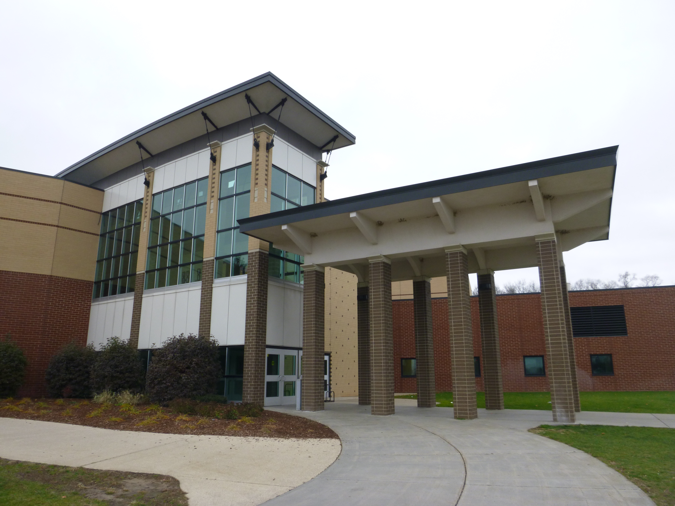

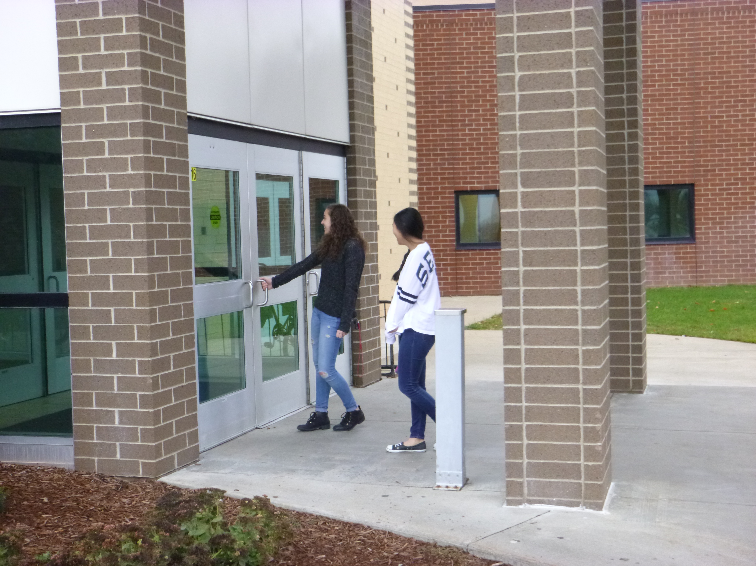
We will go inside the building. There will be signs to help me find where to go. They will look like this:

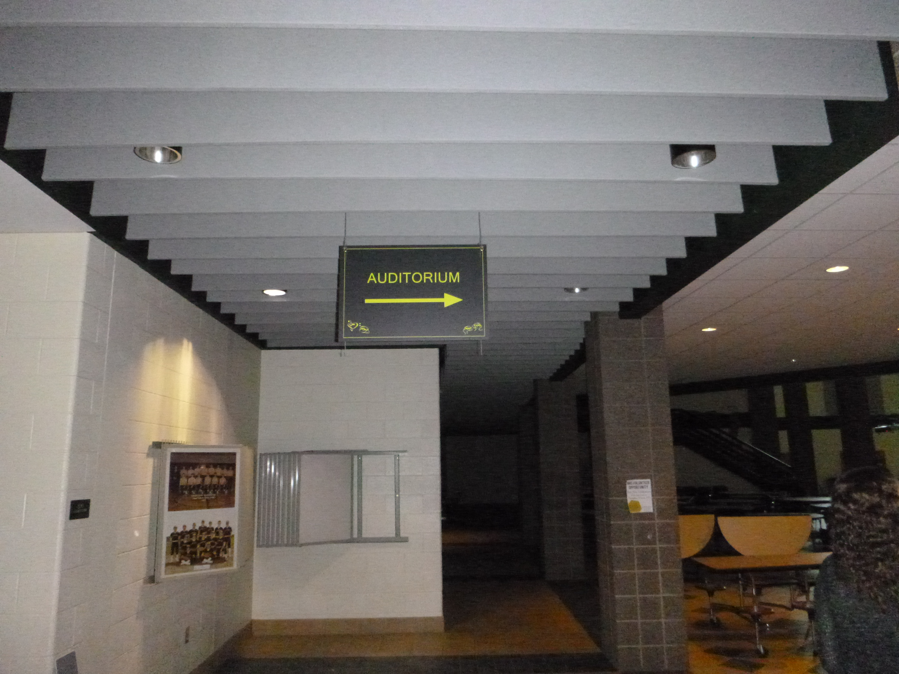

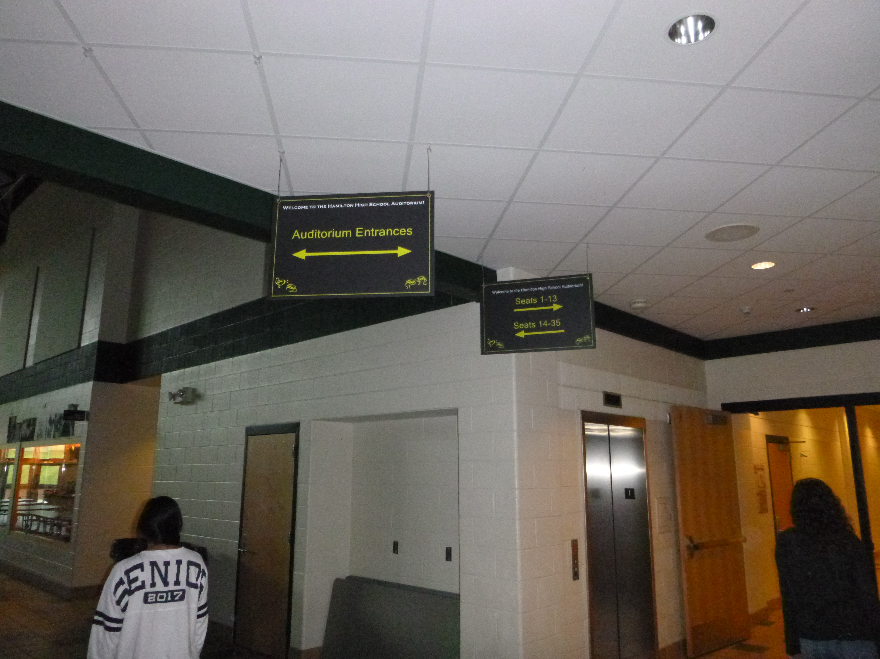
We may have to stand in line to get our tickets. I will stand nicely and quietly while we wait.

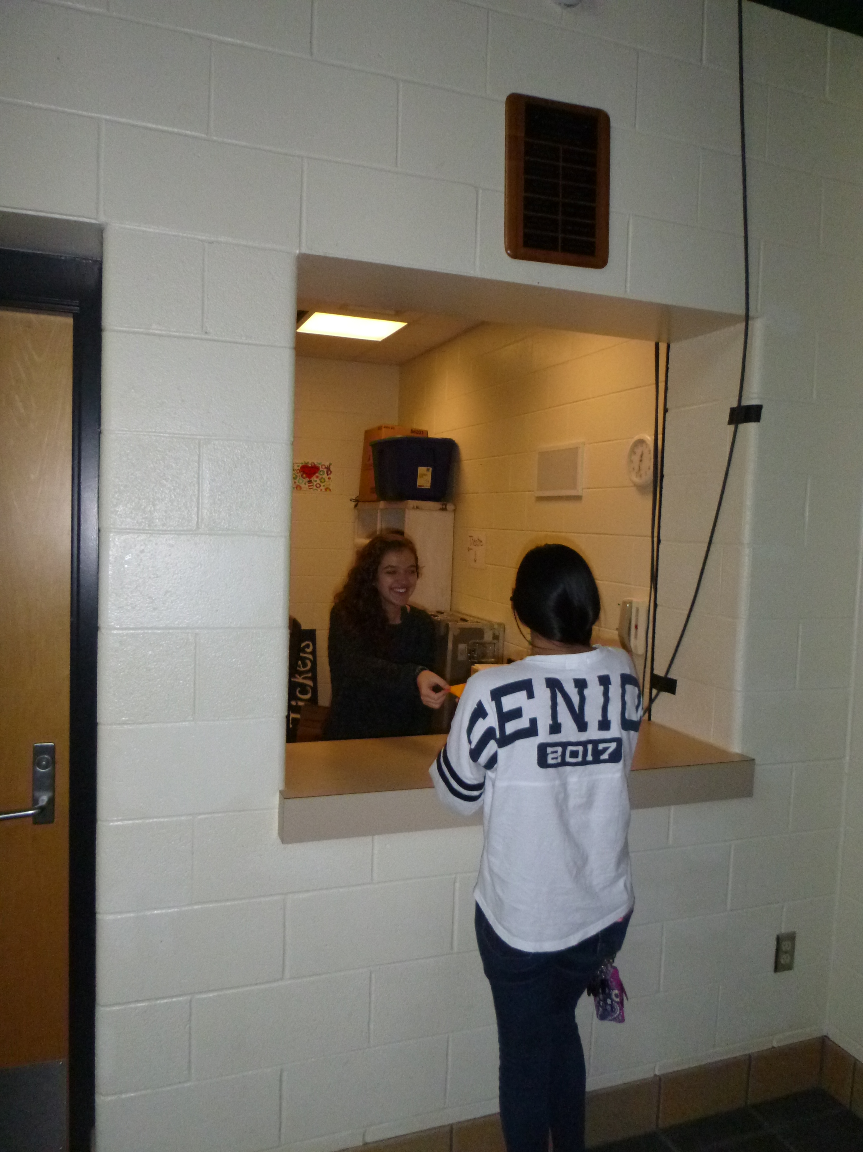

Before we go into the theatre, we will see the bathrooms and water fountains. If I need to use the bathroom, I can ask. If I need a drink of water, I can ask for one. I might have to wait in line for the bathroom. I will stand nicely and quietly while we wait.

When we are ready to go to our seats, we will head into the theatre. It might be crowded in the lobby. We will wait our turn. I will walk slowly in the lobby.

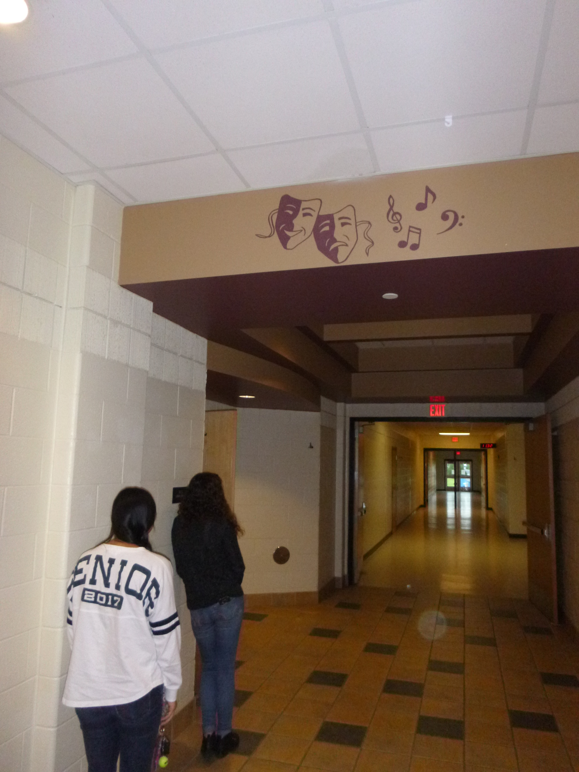

Then we will go inside the theatre. The seats in the theatre are very colorful.
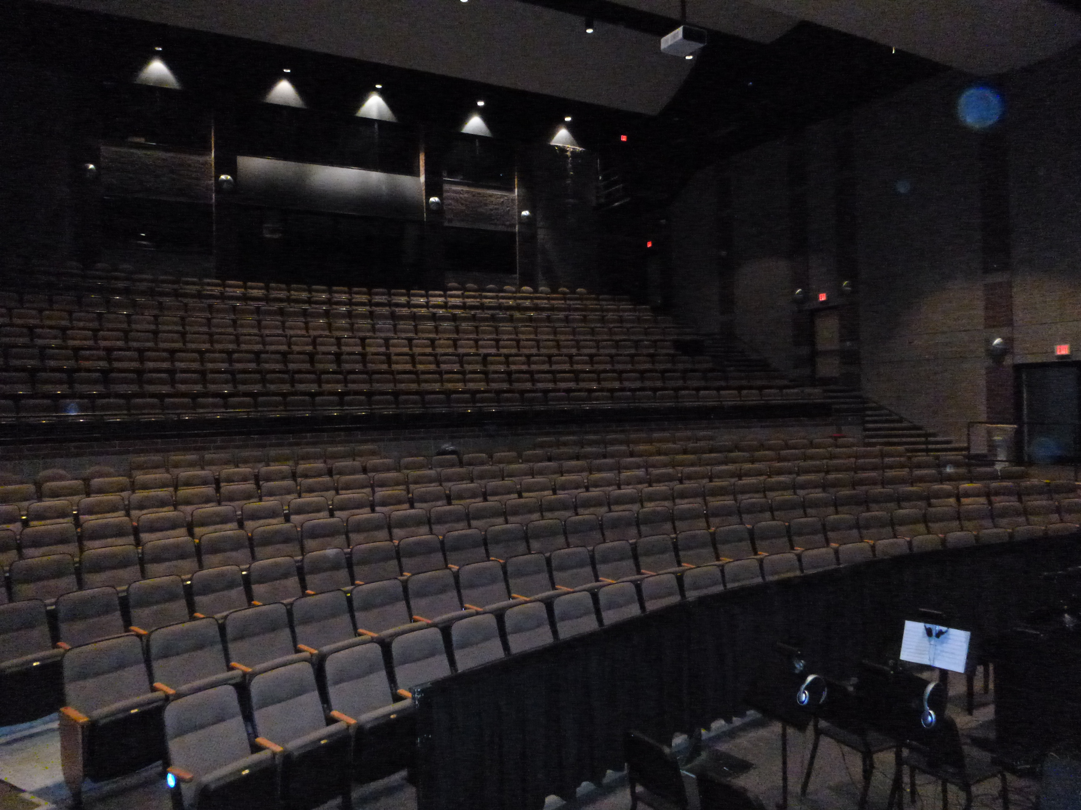
We will show our tickets to a person, who is called an usher, who will tell us where to go. They will also give us a program that will tell me about the show and who is performing.

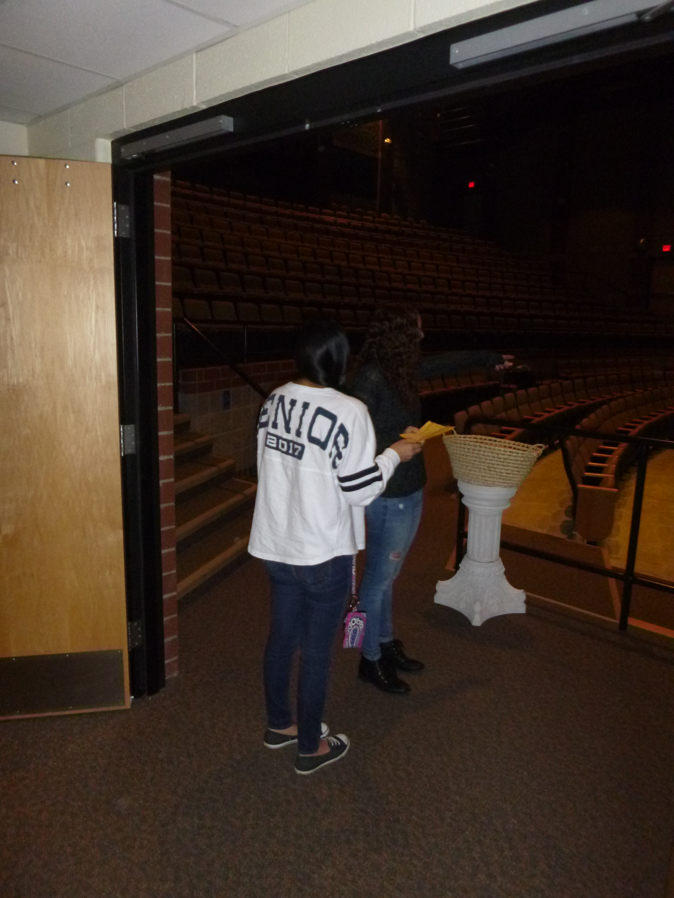

The numbers on the tickets tell us where we have to sit. It is not a choice.

Hamilton High School Theatre Presents
Little Women
March ___28___ at __2pm__
Row _____E_____
Seat _____12_____

When we get to our seats, I will sit down nicely. If I have any questions, I can talk to a volunteer.
I will wait quietly for the show to start. Sometimes it is hard to wait. I can take deep breaths, squeeze a fidget or hold hands to make waiting easier.

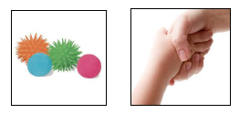
When it is time for the show to start, someone will ask everyone to turn off their phones. The theatre will get darker and everyone will get quiet. I will try to be as quiet as I can during the show, so that I can hear everything.

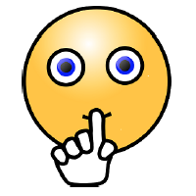

When the show starts, the musicians will begin to play. They will sing a song and start to tell the story of Little Women. If any music or sounds are too loud, I can cover my ears, wear my headphones, or hold my Mommy or Daddy’s hand.

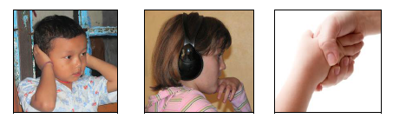

I will have a lot of fun at the show! There will be a lot of singing and dancing. Sometimes it will be loud. If it is too loud, I can cover my ears, wear my headphones or hold my Mommy or Daddy’s hand. I know that even though the singing can be loud and can feel scary, none of the noise can hurt me.
Sometimes I may think the show is a little scary. If I am scared, I can cover my ears, hold my Mommy or Daddy’s hand, or hug my Mommy or Daddy.

If I need a break, I can go to a quiet or activity area where I can rest or play quietly until I feel better. When I feel calm enough, I can go back into the theatre and watch more of the show.
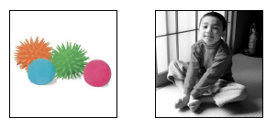
After each song, some people will clap. Clapping in nice because it tells the actors you liked their song. If I want to clap, I can. I don’t have to clap if I don’t want to. I can cover my ears, wear my headphones, or use earplugs if the clapping gets too loud.
In the middle of the show, we will have a break. This break is called Intermission. During the break, many people will stand up to go get a drink or to use the bathroom. If I want to, I can ask for a snack or a drink.

After the break, everyone will come back and sit down in their seats again. It will get darker and quieter again, just like at the beginning of the show. The musicians will start to play again and the actors will finish telling the story of Little Women.

At the end of the show, all of the actors will come out on stage. This is called a curtain call. Many people will clap a lot so the actors know how much they liked the show. The actors will bow.
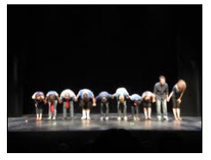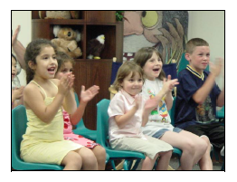
If I want to clap, I can. I don’t have to clap if I don’t want to. I can cover my ears, wear my headphones, or use earplugs if the clapping gets too loud.
After the show is over, we will go out of the theatre and through the lobby to our car. It will be crowed when people are leaving. We will have to wait our turn to leave. I will wait calmly until it is our turn. If I need to get through the crowd, the best way to move through crowds of people is to say “Excuse me.” When you say “excuse me,” it lets people know you would like to get by them. A “Thank You” afterward is also nice!

I am very happy and excited to go see Little Women!

